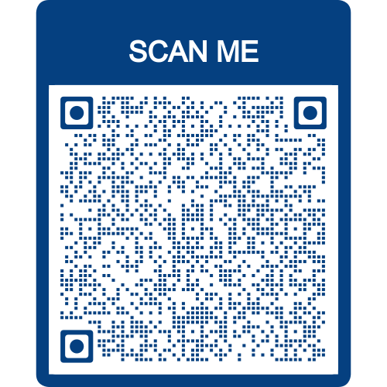
IF YOU ARE INTERESTED 1) SCAN THE QR CODE AND REGISTER AND 2) FILL OUT THIS FORM AND RETURN TO YOUR CYBER FOUNDATIONS TEACHER BEFORE THURSDAY, APRIL 28, 2022.
June 2 Health Science Workshop: Students will learn aspects of First Aid, CPR, Vital Signs, and listening to body sounds. Students may have interactive experiences with anatomy such as tracing the blood through the heart and bone ID.
June 6 Automotive workshop: Students will learn basic auto maintenance, how to check fluid levels, scheduled maintenance, and be introduced to a CNC router.
June 9 Law and Public Safety Workshop: Students will learn about rule of law, military service, CPR and first aid, and firefighting.
Each workshop will last from 8:00 a.m. until 2:00 p.m. on the date above. Both breakfast and lunch will be provided by the South Tippah School District. Transportation to and from the Tippah Career and Technology Center MUST be provided by each individual participating. Students must be picked up by 2:00 from the Tippah Career and Technology Center.
These workshops are currently limited to 8th graders only. You will be notified by your Cyber instructor at a later date if you were selected to participate. Spots will be filled on a first come, first serve basis and spaces will be limited for safety reasons.
By signing the document below, you agree not to hold the South Tippah School district responsible for any accidents that may occur during the student workshops. In turn, two instructors will be guiding your students through each class.
Student name: ________________________________ Age:_______________
School:_________________________Email:______________________________
Signature of parent or guardian: Date:
_________________________________ ________________
Parent/guardian phone number:___________________
Emergency Contact name:________________________ Relation to student:__________________
Emergency contact phone number:____________________________________

